Christmas Around the World: December 4th & 5th, 2021
Helpful Hints & Ticket Tips

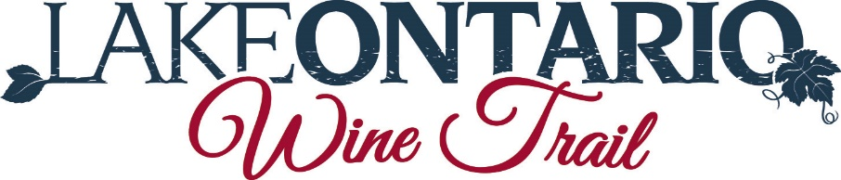

1. You must have an official event ticket to participate in one of our Trail Events. 1 ticket per person. Pre-purchased tickets can be picked up at your first location. All tickets are nonrefundable, and they cannot be exchanged for another Trail event. You can give away or sell your ticket to others. Event information, & participating member locations and phone numbers are printed on each ticket.
Casa Larga Vineyards. JD Wine Cellars. Young Sommer Winery. Colloca Estate Winery.
Rootstock Cider & Spirits. Embark Craft Ciderworks. Old Goat Cidery. Boom Point Winery.
2. Proof of age- please bring proof that you are 21 year of age or older. Each Member location is individually responsible for checking the age of customers, so you may be proofed at more than one location.
3. Please drink responsibly. Each member location has the right to limit or refuse tastings if intoxicated. This could result in your event passport being revoked.
4. Please fill out your name and location on the passport prior to your final stop. This helps us for tracking purposes & better marketing our events.
5. Each attendee will enjoy (3) samples wine, ciders and/or spirits, paired with a traditional dish of the country chosen for each location. Our events are meant to be samples and additional samples are left to the discretion of each winery. You are not required to taste at each location.
6. Transportation & Lodging: tickets do not include transportation or overnight accommodations. We do have a very nice listing of companies who can help you with these types of arrangements. Plan in advance as the weekends tend to book quickly. They are listed in our brochure and on our website.
7. Your ticket is valid for the day you purchase, Saturday or Sunday. Please finish your tour for the day you purchase your ticket.
8. Important Group Size: Purchasing an event ticket gives you a unique opportunity to travel in a larger than normal group without making appointments. However, if you have a group of 6 or more please make reservations at contactus@lakeontariowinetrail.com to reserve your time and to help schedule your visit. All other Members accept buses, please schedule your time with contactus@lakeontairowinetrail.com. This helps to manage crowds & ensure all guests have an enjoyable time.
We hope this helps answers any questions you have about participating in a Lake Ontario Wine Trail event. Any questions, send us an email contactus@lakeontariowinetrail.com

